This information is on the Save the Children Website. We believe the best way we can help the situation unfolding in the Ukraine and surrounding EU bordering countries is to fundraise for a reputable charity. As the children are dressing up for World Book Day and linking this to aspirations for their future it fits in well with what Save the Children are working towards. We will set up a pot on parentpay and you can choose to donate to this in exchange for the children dressing up tomorrow. A small gesture we know but helps make sensible links for the children in a format they can understand. We will be talking to the children in an aged appropriate way this week – there is some advice at the end of the information below to help you with this at home as we know children are asking questions.
M Mackenzie and all the staff

Ukraine's children are living in terror. They face ever-present danger – of being killed, injured or suffering severe emotional distress.
The war is forcing children and families to shelter in basements and bomb shelters to escape explosions.
They have already lived through eight years of conflict, enduring violence, shelling, and being forced to flee their homes.
7.5 million Ukraine children are now in danger.
Amid freezing temperatures, power cuts and food shortages, every day is a struggle to survive. Families are forced to flee their homes.
They need urgent help accessing water, shelter, and food.

We want to deliver lifesaving aid to 3.5 million vulnerable children and their families by:
· Working in Poland, Romania, and Lithuania, providing lifesaving aid to many of the 100,000 that have fled their homes in terror
· Distributing essential supplies and winter kits of clothing and blankets as temperatures plunge below freezing
· Providing cash and vouchers assistance to families to meet basic needs like food, rent and medicines
· Offering vital mental health and psychosocial support to children and their families
· Providing access to safe, inclusive, quality education

Before the war, 1.5 million Ukrainians were already displaced thanks to eight years of conflict.
That situation now looks to get even worse as:
- 400,000 children live in communities at highest risk from violence
- 2.9 million people in Ukraine were already in need of humanitarian assistance
- 7.5 million girls and boys are now at risk throughout Ukraine
- 7 million people are anticipated to be displaced

HOW WE HELPED OLHA*
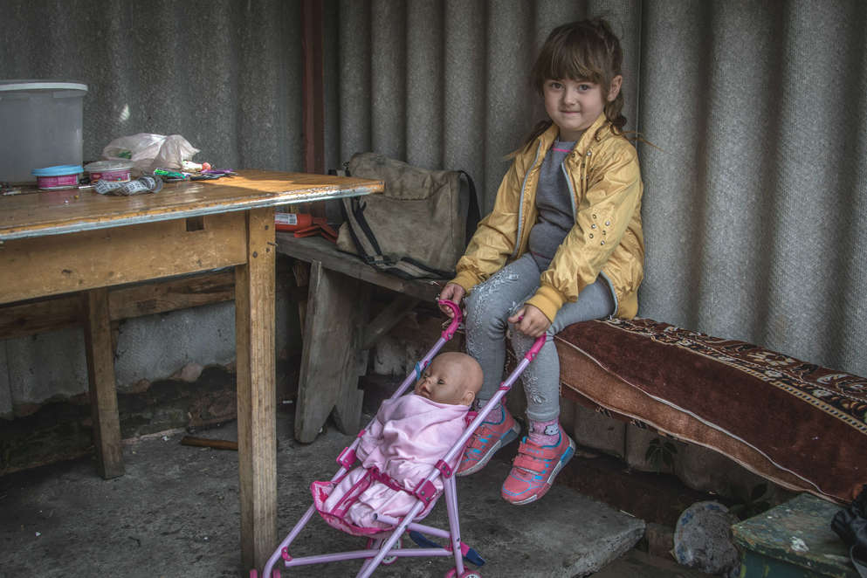
Over a quarter of a billion children are out of school, and children in conflict suffer the most.
Six-year-old Olha* lives with her family on the frontline, in Eastern Ukraine.
She's super ambitious and can't decide between being a dancer, a cook, a police officer or a doctor when she's older.
We helped her get one step closer to achieving her goals with educational resources and social activities at a local Save the Children community centre.
FIVE TIPS FROM A PSYCHOLOGIST AND CHILD COUNSELLOR
Ukraine’s 7.5 million children, like Olha*, pictured above, are caught in the middle of the war with Russia.
Their lives are at risk. So is their mental health and the potential for long-term trauma.
But perpetual social media, news and conversations between adults mean that other children around the world – those not close by or directly affected by it – are also very aware of the crisis.
Many are frightened and don't know what to expect.
They have questions.
So, to help parents, family and care-givers navigate the overwhelming task of responding to children's fears and worries, Ane Lemche, a psychologist and child counsellor at Save the Children, has shared five tips on how to speak to children about war:
1. MAKE TIME AND LISTEN
Give children the space to talk when they want to – even if you're in the middle of something else.
Encourage them to tell you what they know, how they feel and to ask you questions.
2. TAILOR THE CONVERSATION TO THE CHILD
Older children will need more details while younger ones may be satisfied just by understanding that sometimes countries fight.
Be informed, keep calm and answer questions honestly. Begin with simple information – too much detail may overwhelm and cause anxiety.
3. VALIDATE THEIR FEELINGS
Speak to the child about how they feel. It is important that children feel supported in the conversation. They should not feel judged or have their concerns dismissed.
When children have the chance to have an open and honest conversation about things upsetting them, they can feel relieved.
4. REASSURE THEM
Remind them that this is not their problem to solve. Adults all over the world are working hard to fix this.
They shouldn't feel guilty playing, seeing their friends and doing the things that make them feel happy.
5. GIVE THEM A PRACTICAL WAY TO HELP
For example, they could start fundraisers, write letters to local decision-makers or create drawings for peace.
Children who have the opportunity to help can feel like they are part of the solution instead of feeling helpless.
DONATE TO OUR EMERGENCY FUND NOW
Our Emergency Fund is special reserve of money which ensures we have the funds ready to help children through crises like the Ukraine conflict.
We're working quickly to assess what support children and families need and we're ready to provide life-saving aid.
Please give what you can today

